TRANSCRIPT

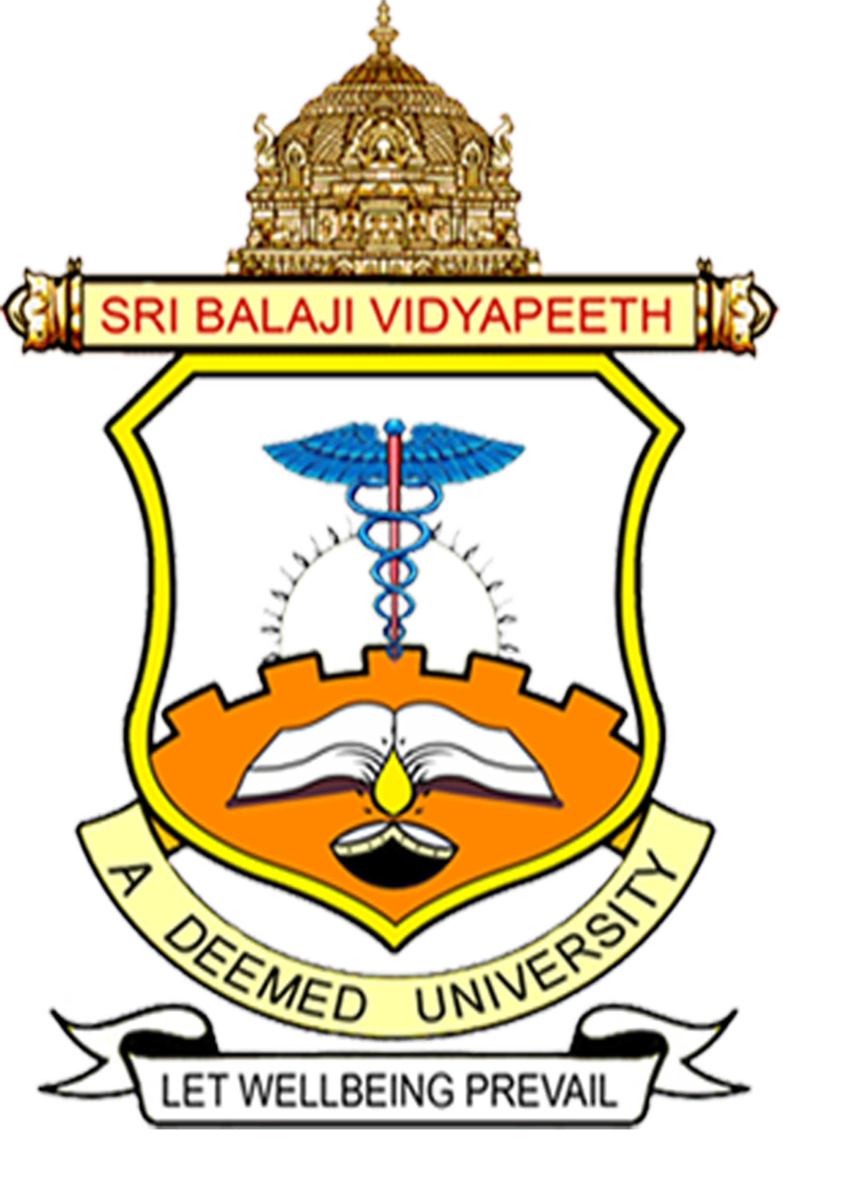

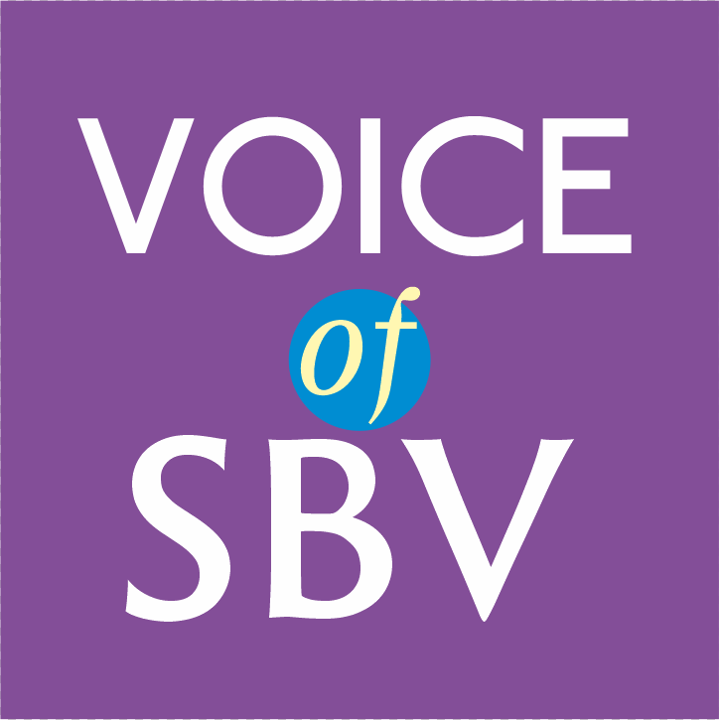

Theme: Drug and substance abuse
Dr.Shree Lakshmi Devi
Professor and Head of Pharmacology
Shri Sathya Sai Medical College and Research Institute
Sri Balaji Vidyapeeth
Chennai
Greeting and warm wishes from Sri Balaji Vidyapeeth. I am Dr.Shree Lakshmi Devi Professor and Head of Pharmacology; Today I will share my knowledge on Drug and substance abuse.
“When you can stop, you don’t want to and when you want to stop, you can’t that’s addiction”. The common drugs abused are hallucinogens or psychomimetic agents, opioids like cannabis, marijuana and cocaine, alcohol and amphetamine. 141 million all over the globe consume cannabis. Next in the competition are amphetamine and ecstasy with around 30 million consumers. Abuse of heroin and other opioids is less common when compared with other drugs and is taken up by around 8 million people worldwide(1).
Men are more common drug abusers when compared to women. Environmental impact in younger population, prisoners and street children are more subjected to drug abuse. The commonly used terms drug dependence, abuse, and addiction has long elicited confusion among students. Dependence, or “physical” dependence, produced when there is progressive pharmacological adaptation to the drug resulting in tolerance. A withdrawal syndrome ensues in which the adaptive responses are now unopposed by the drug. The appearance of withdrawal symptoms is the cardinal sign of “physical” dependence. Addiction is produced by repeated drug use; addiction leads progressively to compulsive, out-of-control drug use.
Drugs of abuse fall into three basic category: The Depressants like barbiturates and opioids: these cause CNS depression. The second group are the stimulants: These cause stimulation of the CNS, resulting in alertness and increased bursts of activity. They cause tachycardia, raised blood pressure and behavioral changes such as agitation, and impaired judgment. In severe cases, there may be delusional psychosis. The last group are the Hallucinogens: These cause hallucinations and an "out of this world" feeling of dissociation from oneself. Hallucinogens may cause distorted sensory perception, delusion, paranoia and even depression. Examples include ecstasy, mescaline and LSD(2)
The common cause of drug abuse among students are peer pressure and curiosity. The smallest step in the right direction ends up being the biggest step of your life. Students beware of experiencing the heaven but actually its a path to hell. A hallucinogen like LSD can cause permanent alternation of vision, increase the risk of trauma, and infertility. It doesn’t affect the self but the entire family is mutilated. The family members are indirect victims of drug abuse. Drug abusers are more prone to contact infectious diseases like HIV due to needle sharing. Accidents and suicide are common among drug users.
In India, The Narcotic Drugs and Psychotropic Substances Act, (NDPS Act) from 1985 works towards eradicating the fast-growing problem which has been known to consume nations like Mexico and even the United States of America. With the help of this Act and its further amendments as per the needs of the society in 2001 and 2014, India has been very stringent on anti-drug petitions and has been persistent in punishments for drug trafficking and drug endorsements. India has enforced imprisonment for 6 month to one year for consumption of drugs like morphine, cocaine and heroin(3).
A valid method of screening for drug abuse in schools and colleges will reduce addiction and enhance early treatment. Tools like the Problem Oriented Screening Instrument for Teenagers (POSIT) available by the National Clearinghouse for Alcohol and Drug Abuse Information (4). The schools and institution should conduct regular awareness program to prevent drug abuse among students. Parent can prevent abuse among children by following a four step process: communicate to children about the risks of drug use and misuse, listen to children when they speak about peer pressure, and be supportive of their efforts to resist it, set a good example, Children of parents who misuse drugs are at greater risk of drug addiction, strengthen the bond: a strong, stable bond between parent and children will reduce child's risk of using or misusing drugs. (5). Students, the best way to prevent drug addiction is to say “NO to drugs”
Thank you stay safe

References:
1. Institute for Health Policy, Brandeis University. Substance abuse: the nation's number one health problem; key indicators for policy. Princeton, N.J.: Robert Wood Johnson Foundation,1993.
2.Mandal, Ananya. "What is Drug Abuse?". News-Medical. 02 November 2021. https://www.news-medical.net/health/What-is-Drug-Abuse.aspx
3. Drugs and Narcotics in India and their Illegal Consumption: Helpline law. https://www.helplinelaw.com/national-and-social/DNITI/drugs-and-narcotics-in-india-and-their-illegal-consumption.html
4. The Adolescent Assessment/Referral System Manual. DHHS Publication No. (ADM). Rockville, Md: National Institute on Drug Abuse, US Department of Health and Human Services, 1991:91-1735
5. Mayo clinic Drug addiction substance use disorder. https://www.mayoclinic.org/diseases-conditions/drug-addiction/symptoms-causes/syc-20365112#

